Village Avatar CV Pipeline Spec
Oct 9, 2026 · @Iraj Moradi

TL;DR
Build the WOW path first: SAM 3 cuts each friend out of the photo, LAM turns their face into a talking 3D head, and Audio2Expression lip-syncs it to their ElevenLabs voice. Then build the MVP path, which turns each cutout into a stylized, rigged, walking villager with TRELLIS 2 and UniRig. Both run on one Vultr L40S (48 GB, $1.67/hr on demand) as a single FastAPI GPU server.
Stage | Model | Source | License | Output | Speed (reported) | Used in
Segment people + clothing | SAM 3 | Meta | SAM License, gated HF | Instance masks from text prompts | ~30 ms per image on H200 | Both
Talking head | LAM (LAM-20K) | Alibaba Tongyi | Check repo | Animatable Gaussian head (FLAME) | 1.4 s | WOW
Audio to face motion | LAM Audio2Expression | Alibaba Tongyi | Check repo | Expression coefficients per frame | Real time | WOW
Body proportions | SAM 3D Body | Meta | SAM License, gated HF | MHR rigged body mesh, GLB/BVH | Seconds | WOW (stretch)
Stylize crop | Gemini image editing | Google API | API terms | Front-facing chibi T-pose image | Seconds | MVP
Image to mesh | TRELLIS 2 | Microsoft | MIT | Textured GLB with PBR | ~1 to 3 min | MVP
Auto-rig | UniRig | VAST / Tsinghua | Permissive | Skeleton + skin weights, rigged GLB/FBX | ~53 s on A100 | MVP
Backup mesh | Hunyuan3D 2.1 | Tencent | Tencent community license | Textured GLB | Minutes | MVP fallback
Build order: SAM 3 server, then LAM head + voice demo, then TRELLIS 2 + UniRig villagers, then SAM 3D Body proportions if time allows.
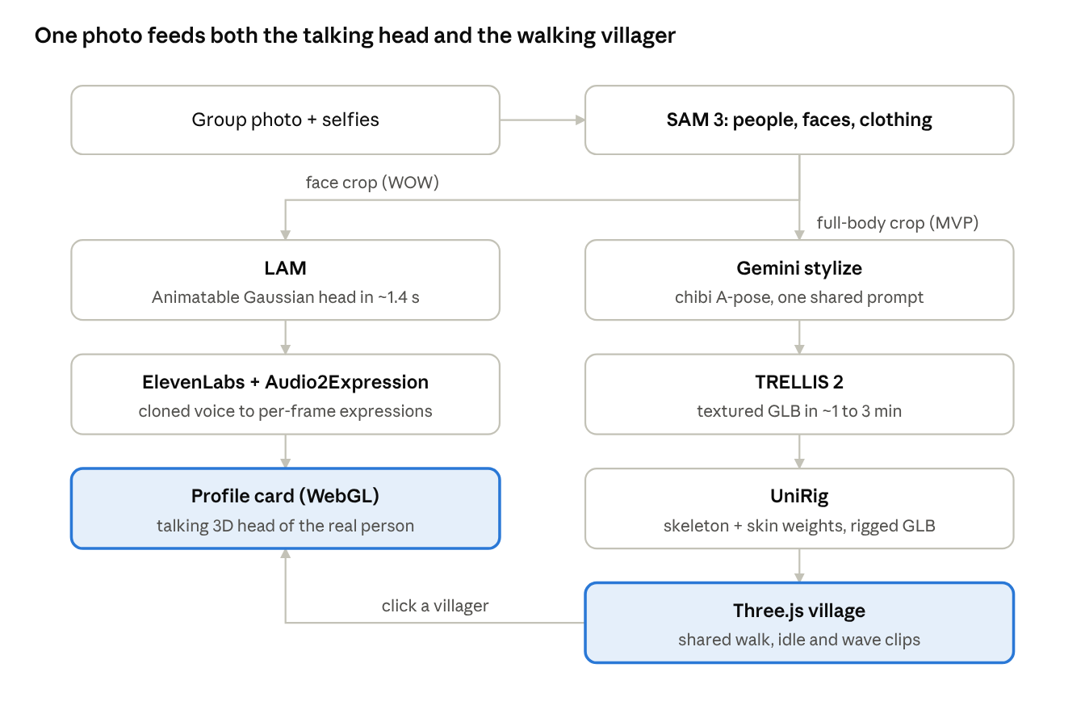
avatar pipeline · SAM 3 splits into WOW and MVP lanes
SAM 3 runs once and feeds both lanes. Clicking a walking villager opens that person's talking head.

Stage 0: Segmentation and identity (shared)
SAM 3 runs once per uploaded photo and feeds both pipelines. Its text-prompt mode (Promptable Concept Segmentation) returns every instance of a noun phrase, so no clicking is needed.
Input: one group photo, plus one optional selfie per person (strongly recommended, it makes every downstream model better).
- Load sam3 image predictor once at server start, keep it on GPU.
- set_text_prompt("person") on the group photo. Keep masks with score above 0.5 and area above 2% of the image.
- For each person mask, crop the bounding box with 10% padding, composite onto a white background, save as person_{i}.png.
- Run SAM 3 again on each crop with prompts "face", "hair", "shirt", "pants", "shoes". Save each mask and the median RGB of its pixels to traits.json.
- Face crop: take the "face" mask box, expand 1.6x to include hair and chin, resize to 512x512. This is the LAM input.
- Identity: return all crops to the frontend. Each user taps "this is me" during onboarding. Store user_id → crop_id.
- If a selfie exists, use it instead of the group crop for the face (higher resolution, frontal).
Outputs per user: full_body.png, face_512.png, traits.json (hair, shirt, pants, shoes colors), masks.
Demo talking point: one model, used three ways: instance segmentation of the group, part segmentation for clothing colors, and face extraction for the head model.

WOW pipeline: talking 3D heads (build first)
Clicking a villager opens their profile card with a photoreal 3D head of the real person that speaks in their cloned voice. This lives in the profile panel, not the village, so photorealism is fine there.
A. Head generation (once per user, ~2 s GPU)
- Input face_512.png from Stage 0.
- Run LAM-20K inference (huggingface-cli download 3DAIGC/LAM-20K). It internally fits FLAME tracking and outputs a canonical Gaussian head.
- Use LAM's avatar export feature to produce the web-ready avatar package (the format the OpenAvatarChat WebGL renderer loads).
- Upload the package to object storage as avatars/{user_id}/head/. Mark head_ready = true in the DB.
B. Voice lines (per message)
- Text comes from the Gemini mayor agent or a canned line ("Yo you're slacking bro").
- ElevenLabs TTS with the user's cloned voice ID → line.mp3 (also send 16 kHz WAV to the GPU server).
- GPU server runs LAM Audio2Expression on the WAV → per-frame expression coefficients, saved as line_expr.json.
- Store both under voice_lines/{line_id}/. Pre-generate 5 to 10 lines per user at onboarding so the demo never waits.
C. Frontend playback
- Profile card mounts the LAM WebGL renderer with the user's head package.
- On "play", start line.mp3 and step through line_expr.json frames keyed to audio.currentTime.
- Idle state: loop a small blink and head-sway expression track when no audio is playing.
D. Stretch: SAM 3D Body proportions
- Run SAM 3D Body on full_body.png. Output is an MHR mesh with skeleton (GLB) plus shape parameters.
- Read limb lengths and height from the MHR skeleton. Normalize against a reference adult.
- Apply those ratios as bone scales on the MVP villager rig, so tall friends are tall and broad friends are broad.
- Demo line: "the village body is shaped by a 3D body estimate from your photo".
Fallback if LAM install fights you: skip 3D heads and show the SAM 3 face crop as a 2D card with a simple jaw-flap driven by audio amplitude. Still demoable, much less wow.

MVP pipeline: walking villagers
Each friend becomes a stylized chibi character that walks around the village in Three.js. Stylizing before meshing fixes the uncanny photoreal look and gives image-to-3D a clean input.
A. Stylize (Gemini, ~5 s)
- Send full_body.png + traits.json colors to Gemini image editing.
- Fixed prompt: "Chibi low-poly 3D game character of this person, full body, front view, A-pose arms 30° from body, neutral expression, plain white background, same hair, clothing and colors." Keep this prompt identical for everyone so the village has one style.
- Run SAM 3 "person" on the result to strip any background, save stylized.png.
B. Mesh (TRELLIS 2, ~1 to 3 min)
- Input stylized.png. Export GLB with baked base-color texture.
- Post-process in Python (trimesh or Blender headless): decimate to ~10k to 20k triangles, recenter feet at origin, face +Z, scale to 1.0 unit tall.
- If TRELLIS output is bad for a person, rerun with a new seed once, then fall back to Hunyuan3D 2.1.
C. Rig (UniRig, ~1 min)
- generate_skeleton on the GLB, then skinning, then merge.sh → rigged.glb.
- Retarget to a shared humanoid animation set (idle, walk, wave, cheer) so every villager uses the same clips. Map UniRig bone names to the animation set's bone names once, by hand.
- Upload avatars/{user_id}/body/rigged.glb. Mark body_ready = true.
D. Frontend
- Three.js (or React Three Fiber) GLTFLoader + AnimationMixer. One mixer per villager.
- Villagers pick random waypoints on the village navmesh and crossfade idle ↔ walk.
- Click a villager → profile card with the WOW head from the previous section.
Fallback (zero rigging risk): generated head on a preset body
- One pre-rigged chibi body asset with the animation set already attached.
- Run TRELLIS 2 on a stylized head-only image instead of full body.
- Parent the head mesh to the body's Head bone. Tint shirt, pants and shoes materials with traits.json colors from SAM 3.
- Every step still uses CV (segmentation for parts and colors, 3D generation for the head), and nothing can fail at rigging.

Vultr infra
One Vultr Cloud GPU instance, kept warm for the whole hackathon. Vultr Serverless Inference is built for LLMs behind an OpenAI-compatible API and cannot host these models, so do not use it here.
Instance: 1x NVIDIA L40S, 48 GB VRAM, 16 vCPU, 180 GB RAM, Ubuntu 22.04 + CUDA 12.1. $1.67/hr on demand (pricing), about $40/day. A100 80 GB is the backup if L40S stock is out.
VRAM plan: SAM 3 stays resident. LAM and Audio2Expression stay resident (small). TRELLIS 2, UniRig and SAM 3D Body load on demand, one at a time, then torch.cuda.empty_cache(). Peak should stay well under 48 GB.
Process layout: one conda env per model (they have conflicting CUDA extensions), each wrapped as a small worker. One FastAPI gateway + Redis queue in front. Jobs run serially on the GPU.
Endpoint | Body | Returns | Worker
POST /segment | photo URL | crop list + traits.json per crop | SAM 3
POST /avatar/head | user_id, face URL | job_id → head package URL | LAM
POST /avatar/body | user_id, full-body URL | job_id → rigged.glb URL | Gemini → TRELLIS 2 → UniRig
POST /voice/expr | WAV URL | line_expr.json URL | Audio2Expression
POST /avatar/proportions | full-body URL | bone scale JSON | SAM 3D Body
GET /jobs/{id} | none | status, progress, result URL | gateway
Storage: Vultr Object Storage (S3 compatible) for photos, GLBs, head packages, mp3 and expression JSON. The DB (Tiger Data) stores only URLs and head_ready / body_ready flags.
Onboarding UX: segmentation returns in about a second, head in seconds, body in a few minutes. Show the head first and a "your villager is being built" construction-site animation in the village until the body is ready.

Risks and checklist
Risk | Impact | Mitigation
SAM 3 / SAM 3D Body checkpoints are gated on Hugging Face | Blocks Stage 0 entirely | Request access tonight from every teammate's HF account. Fallback: SAM 2 + a person detector
CUDA extension builds (spconv, Gaussian rasterizer, nvdiffrast) | Hours lost | Separate conda env per model. Build each on the Vultr box first, before writing app code
LAM web renderer integration | No WOW head | 2D face card with audio jaw-flap (see WOW fallback)
TRELLIS output looks bad on some people | Ugly villager | Reseed once, then Hunyuan3D, then preset-body fallback
UniRig bones don't match animation set | No walking | Hand-map bone names once, or use preset-body fallback
Group photo too low-res for faces | Blurry heads | Ask for one selfie per person at onboarding
L40S out of stock in region | No GPU | Try another region, or A100 80 GB
Consent for photos and voice | Ethics / judging | Explicit opt-in screen at onboarding. Label AI-voiced messages
Tonight
- ☐ Request HF access: facebook/sam3, facebook/sam-3d-body-dinov3
- ☐ Spin up Vultr L40S, install CUDA 12.1, clone SAM 3, LAM, TRELLIS 2, UniRig
- ☐ Run each repo's demo on one test photo of the team
- ☐ Confirm LAM export package loads in its WebGL renderer
- ☐ Pick the shared animation set and the chibi stylize prompt
- ☐ Stub the FastAPI gateway with the endpoint table above

Sources
- SAM 3 repo · SAM 3 overview (Roboflow)
- SAM 3D Body (ComfyUI wiki) · SAM 3D Body explainer · Rerun SAM 3D Body example
- LAM repo · LAM paper
- LHM repo
- UniRig repo · UniRig on Replicate
- Open-source 3D generators 2026 · TRELLIS 2 vs Hunyuan 3D
- Vultr GPU plans · Vultr Serverless docs

